

Introduction to Web Technologies

**Project**

Teacher: Nataliia Strukalo

Name: Takunda

Surname: Kadyautumbe

Student ID: W66973

Rzeszów 20203

TABLE OF CONTENTS

Introduction and Names......................................................................PAGE 1

Table of Contents................................................................................PAGE 3

Description of Topic and Objectives..................................................PAGE 4

Description of Technologies used......................................................PAGE 5-10

**Description of topic, and objectives**

Essentially my Website is all about gaming and the latest games on the market. It consists of a home page where a user will then be able to select one of 3 categories. These three categories include Action, Racing and Sports. The Website is called Gamers Hub.

The website was made to cater for gamers of all interests but mostly the three mentioned above. The objective of my website is to expose gamers to a wider range of games that they might not have heard of rather than just exposing them to the more common games that the general public are used to playing. The games however are not ranked in order of which games are trending but rather they are just there for users to be exposed to. Each game will have a link to the website where the viewer will be able to go a read and watch more about the game. This means that each game will have a link to the official websites of the games where they will be able to read more about the games and get a better understand and possibly even get reviews on the games.

## DESCRIPTION OF THE TECHNOLOGIES USED

**LITERATURE**

**Home Page**

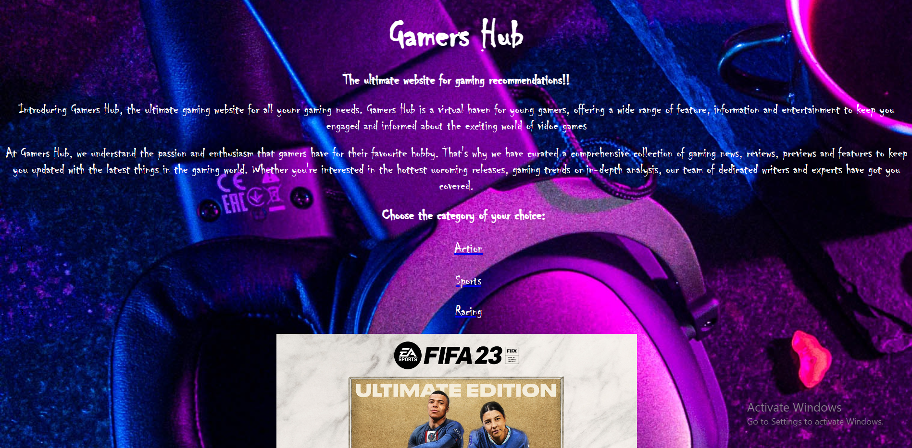

This is the home page where the user will be able to see all about the webpage and from here the user will be able to select the category of their choice from the 3 categories mentioned in the description above. The home page also contains a slider as seen above and here you will see random games that are within the other subpages to this one.

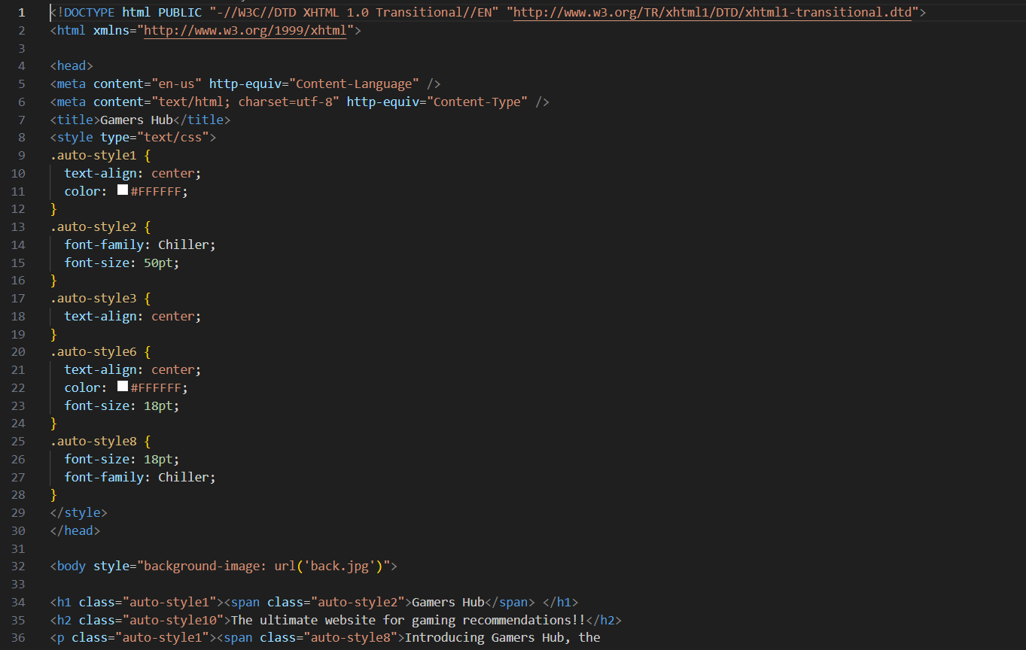

As shown above this is a snippet of the code used to make the home page. The CSS is within the code but it could easily be attached using a different method but when I attempted to attach it to the html is refused therefore I had to embed it within the code for it to run perfectly.

Action Page

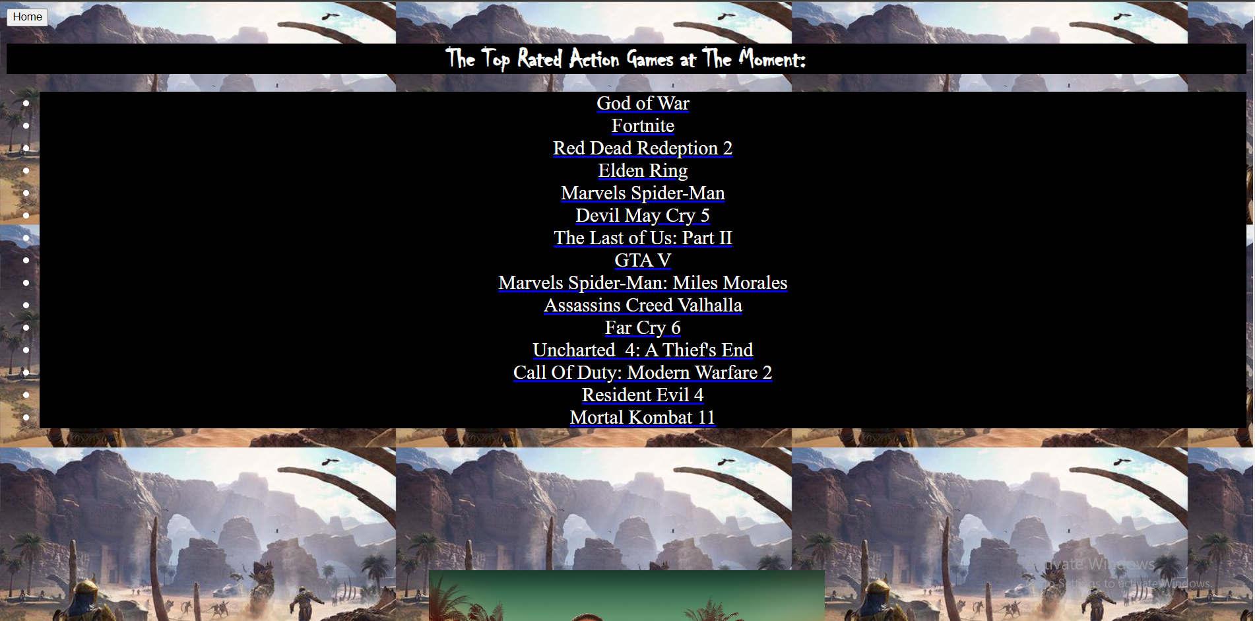

The above page is the Action page where there is a list of random action games and the user will be able to select the game they want to find out more on and if they decide to go back to the home page they can do so by pressing the home button in the top left corner.

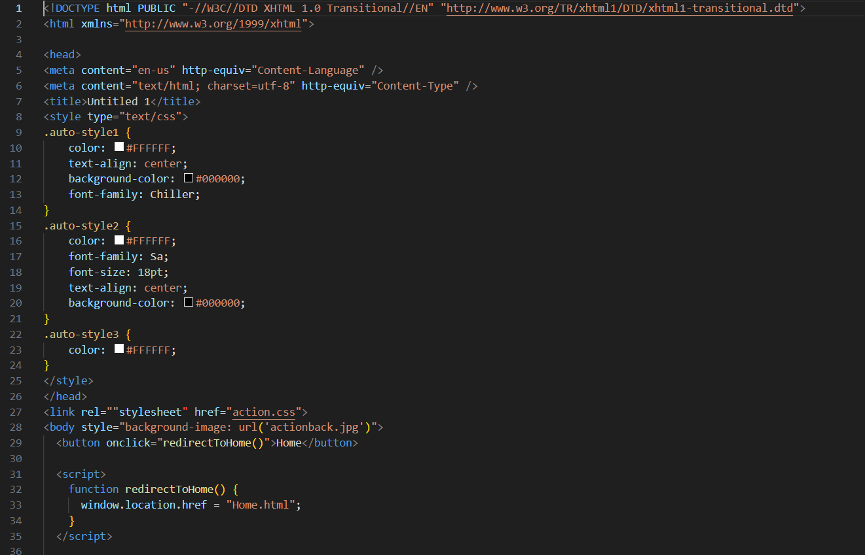

The above image is a snippet of the code used to create the webpage for the action games.

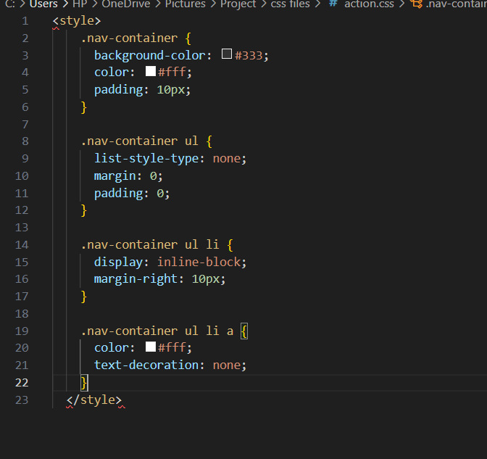

This is the CSS used to the Action webpage.

Racing Webpage

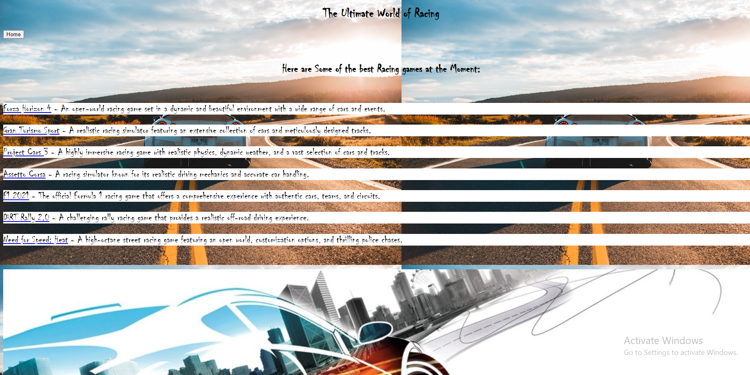

Like the other webpages the Racing Webpage is pretty much the same but this one contains a slider of the best racing games that gamers can play at this point in time.

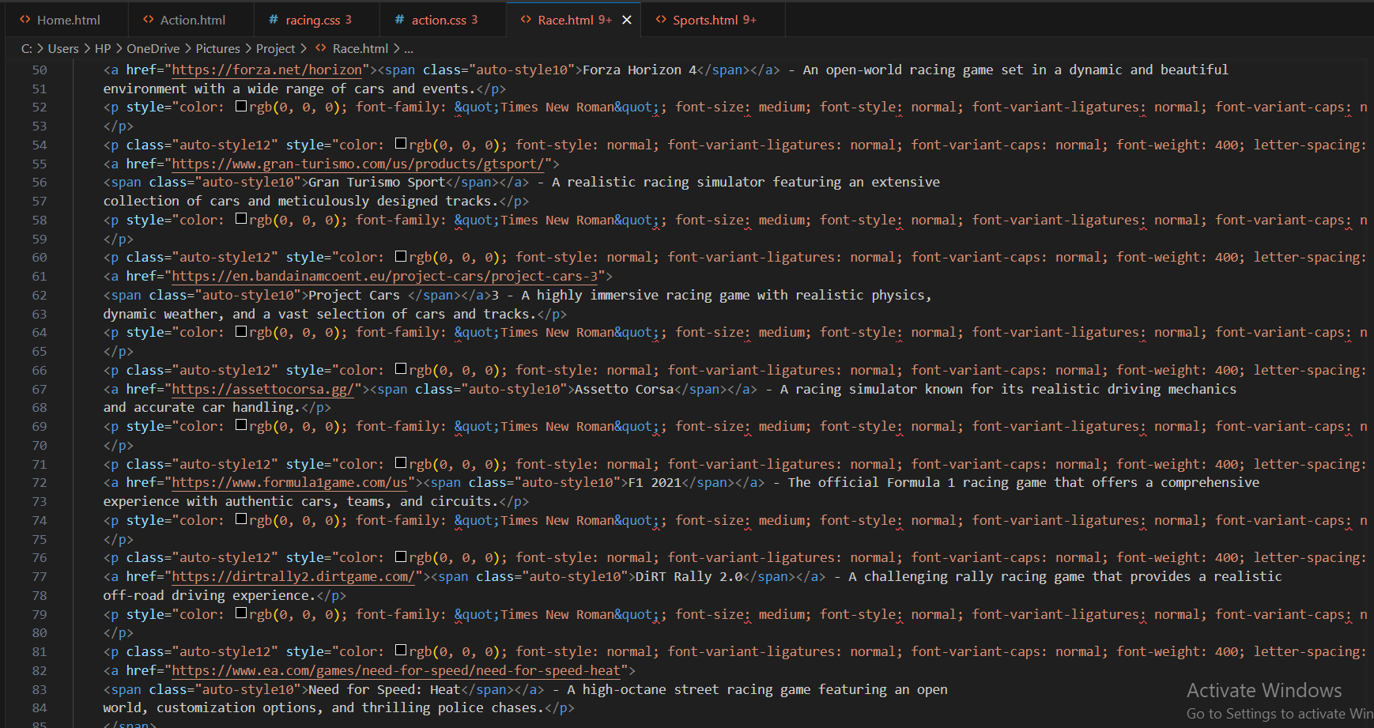

This is a snippet of the code used when creating the racing webpage.

Sports Webpage

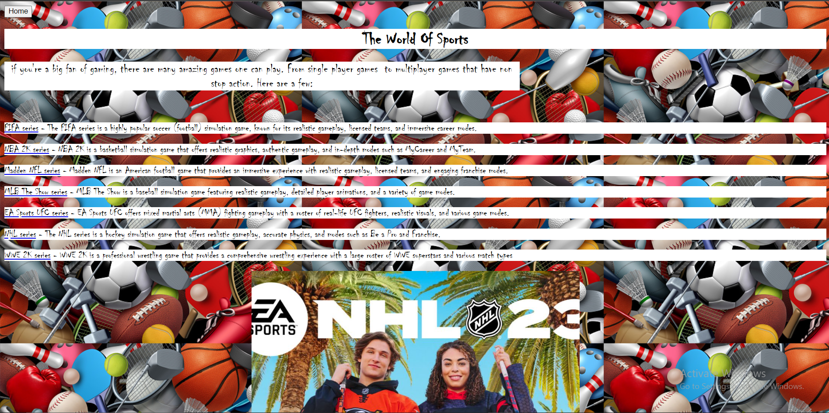

This is the Sports webpage which maybe different to the rest of the subpage because this one unlike the others, gives you a little informaton on what the game games are about and it also allows you to go to the offical webiste of the game where gamers can get deeper and better knowledge of the game.

In conclusion my website is a basic website that just allows usres to gain more knowledge on games and what they are about.